**CMPE 297 – Special Topics in Software Engineering**

**FALL 2017**



**IOS Application Development**

**Assignment 4 - IOS Customer Service App Cloud Assignment**

**Submitted by- Submitted to-**

Anvit Saxena Prof. Chandrashekhar

SJSU ID: 010953436

The main motive of this assignment is to extend the iOS Cloud Service App and store data to the cloud. Below screenshot shows the main page of the app where the data can be saved to the cloud using Save to cloud button as shown in the UI below after filling the details:

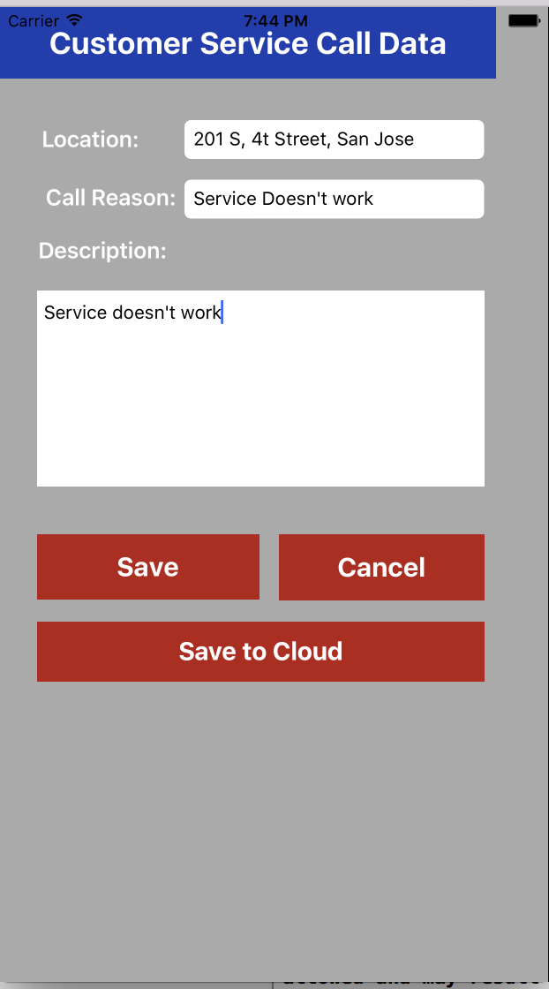

In the below screenshot, we can see the data we stored in the cloud after we click the cloud button.

